How to make Qt sis with Carbide

Author: Johnny Liu Date: 6/18/2010

This method of making SIS is use Carbide + armv5, but we don’t necessary input DOS command like usual, just need to configuration Carbide correctly, then build Carbide project/.pkg file to generate SIS.

**1.**

(1) open Qt\4.7.0-beta1\mkspecs\common\symbian\symbian.conf

(2)Find the line of QMAKE_CXXFLAGS.ARMCC = --visibility_inlines_hidden

Delete the last half part of it, and changed it like below:

QMAKE_CXXFLAGS.ARMCC =

**The diagram like below:**

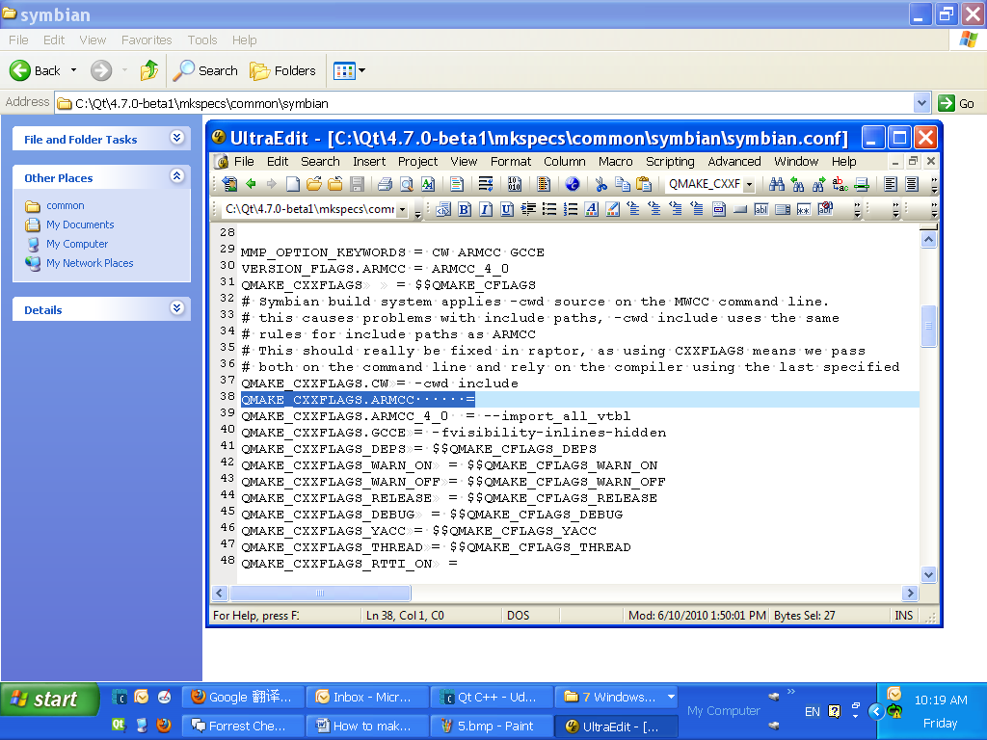

**2.**

In Carbide .pro file, **delete the last sentence of it and build the project**,e.g.delete symbian:TARGET.UID3 = 0xECF9650A. After build the project,the UdpChat_template.pkg will produce a new uid.

This is because if we don’t do this, although every project has different name, and we can make different named SIS for each project, but actually, they are all the same(with same uid). If we install those different named SIS on the phone, it will promote all the SIS are same, and we just can install one SIS of them, the one before will be substituted by the one after, even the name are difference and the SIS are generated from different project.

**After deleted diagram like below:**

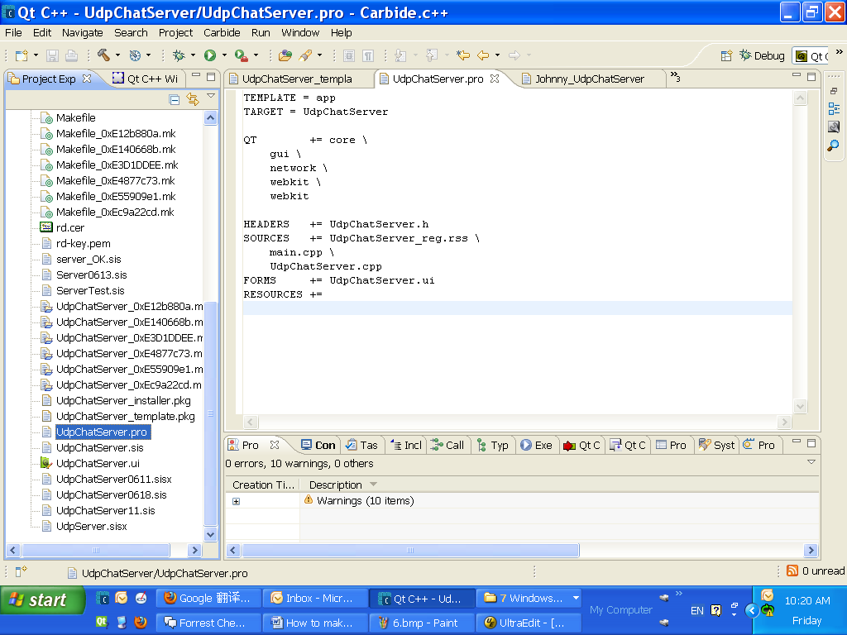

**3.**

Create a new .pkg file with the name of yourself in Carbide project(e.g. yourname.pkg), and copy all of the **\*\*\*_template.pkg** contents in it , then do change as below in your .pkg:

**Change** "/S60/devices/S60_5th_Edition_SDK_v1.0/epoc32/release/$(PLATFORM)/$(TARGET)/UdpChatServer.exe" - "!:\sys\bin\UdpChatServer.exe"

**To**

"/S60/devices/S60_5th_Edition_SDK_v1.0/epoc32/release/armv5/udeb/UdpChatServer.exe" - "!:\sys\bin\UdpChatServer.exe"

**That means we need to switch to the path of armv5 file,and the step 3 must after the step 2, because on step 2, it produced a new uid after build the project.**

**And the other point is important too, that is the uid of the .pkg you created must same with the uid of ***_template.pkg. Usually need to check this every time after build the project.**

**(1)**Make sure the path is already switch to armv5 file in your created .pkg

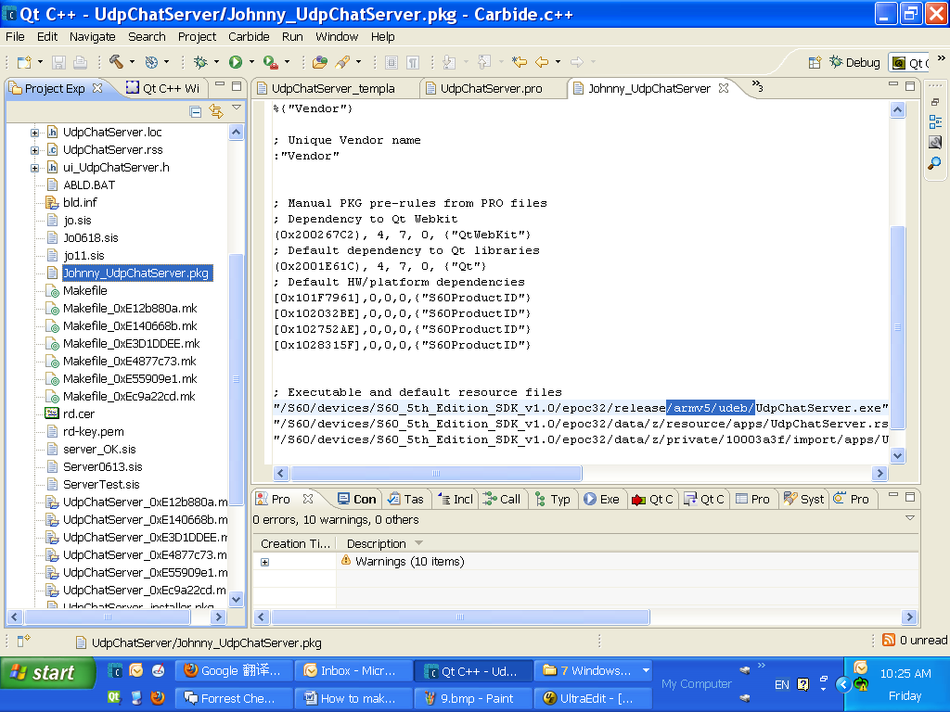

**(2)**Make sure the uid of you created .pkg is same as ***_template.pkg file.

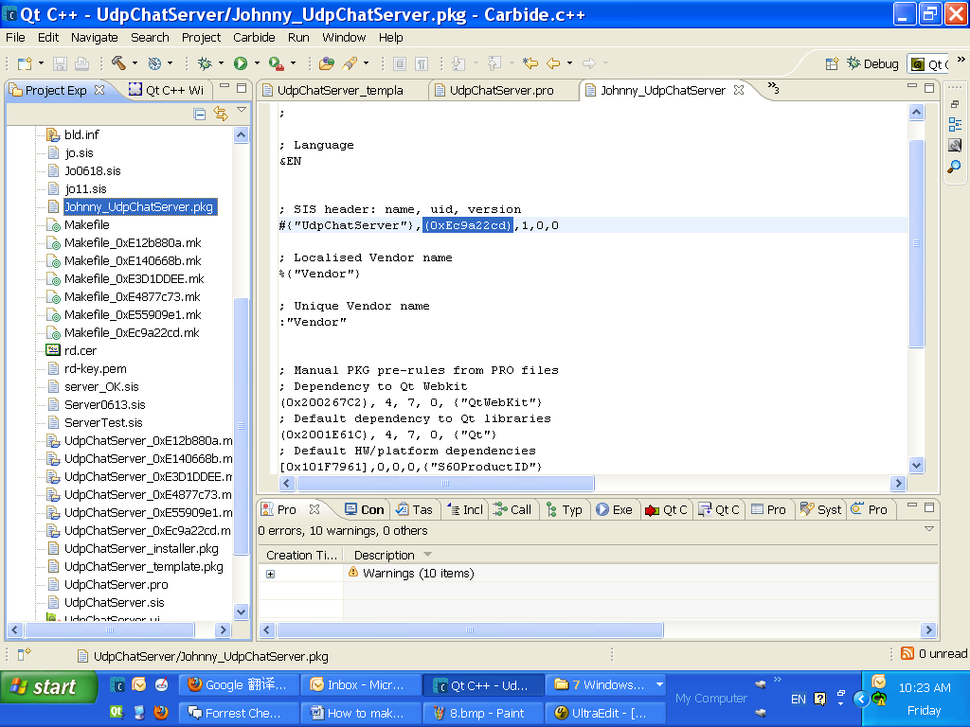

**4.**

In Carbide, change the Build choice from Emulator Debug(WINSCW) to Phone Debug(ARMV5). In the first time, it will Build project automatically.

**The diagram like below:**

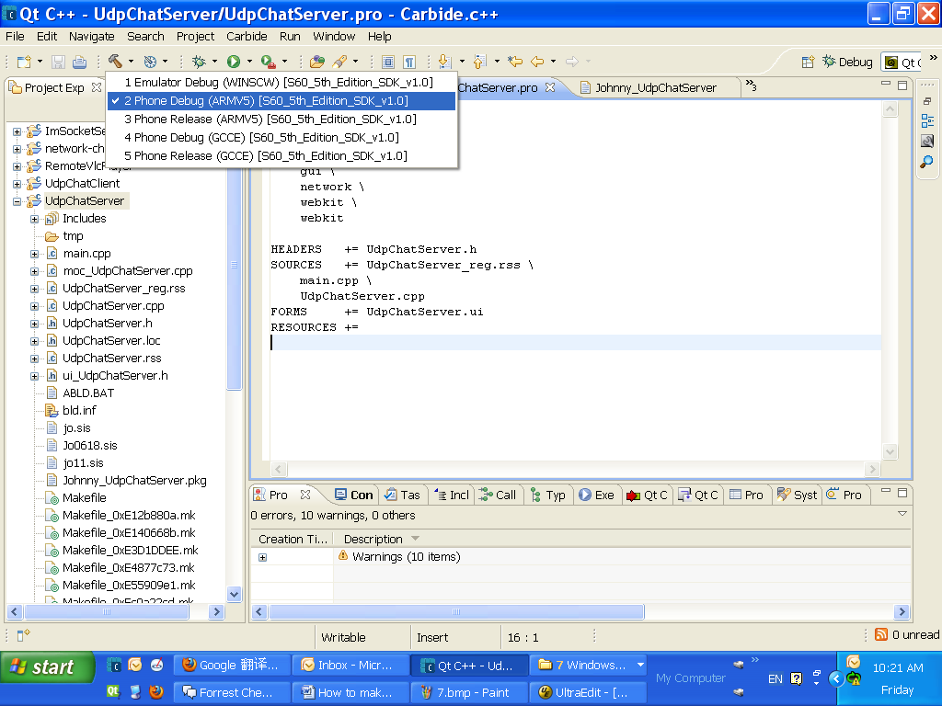

**5.**

After Build the project, you’ll find some new files are produced in C:\S60\devices\S60_5th_Edition_SDK_v1.0\epoc32\release\armv5\udeb.

Those new files are very important,especially .exe files, if them cann’t be produced timely(Can reference files Data Modified), that means some steps are wrong.

**The diagram like below:**

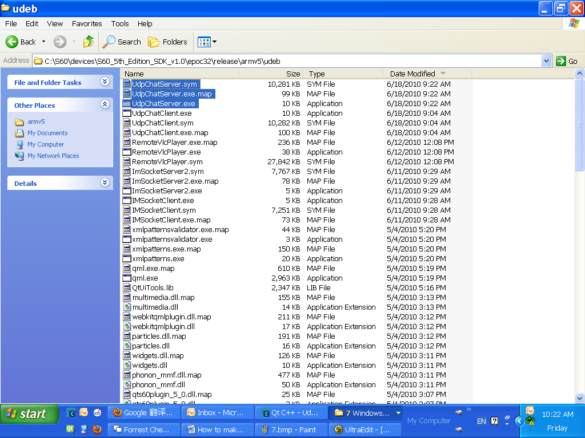

**6.**

Configuration the Carbide like below:

1. Right click the project name and choose the Properties which at the last item, open the **Properties for projectName** dialog like below.

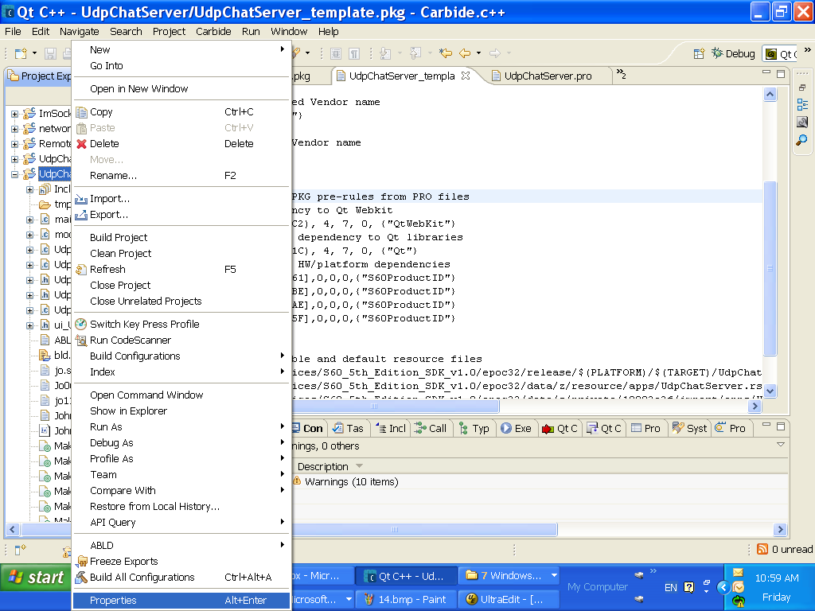

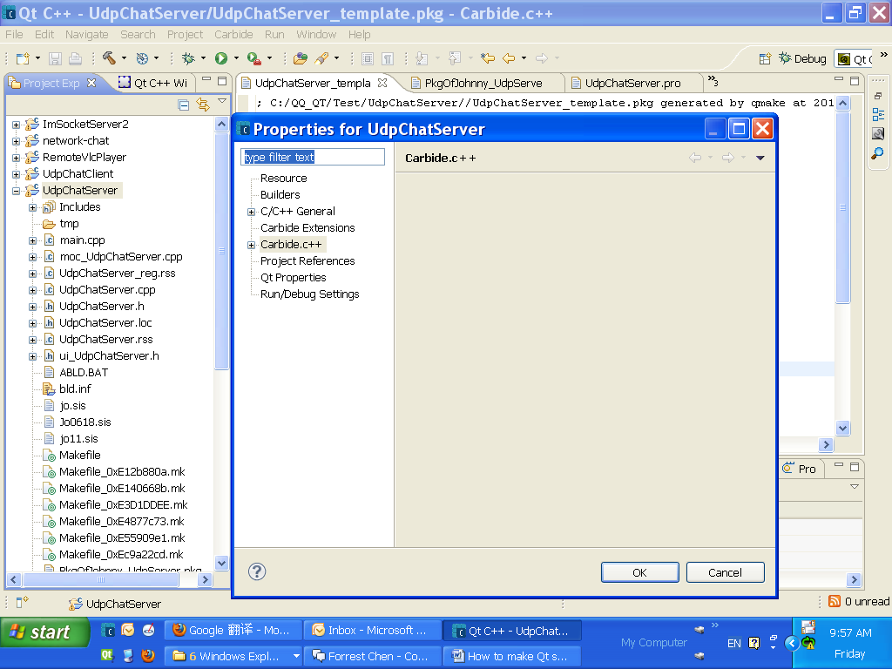

**(2)**Click the plus symbol of Carbide.C++ and choose Build Configurations, the diagram like below:

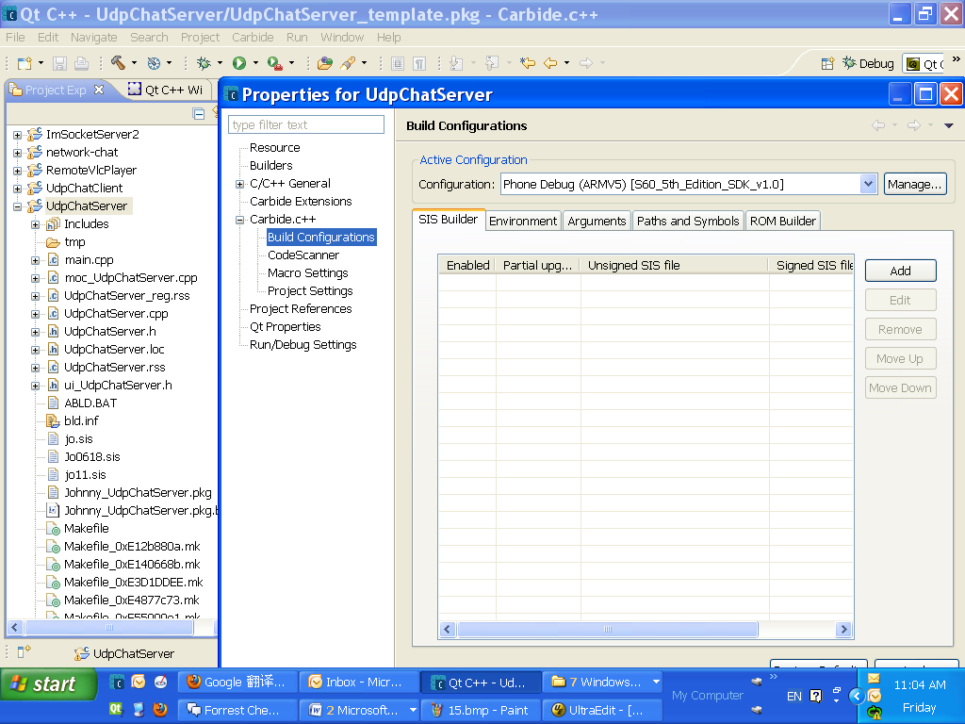

**(3)**Click the Add button and open the SIS Properties dialog like below:

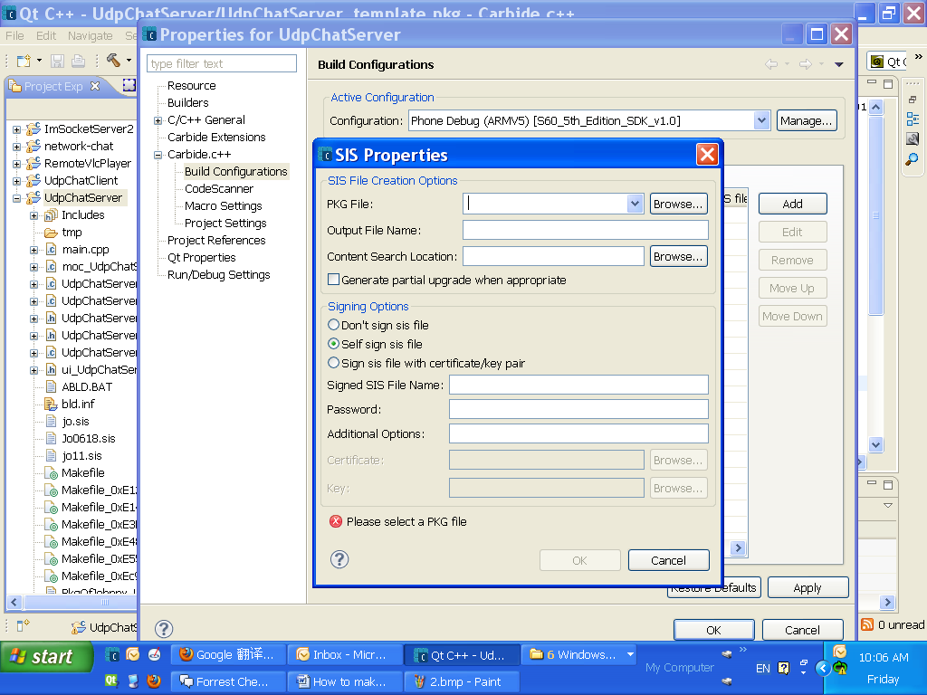

**(4)**Fill the SIS Properties dialog like below:

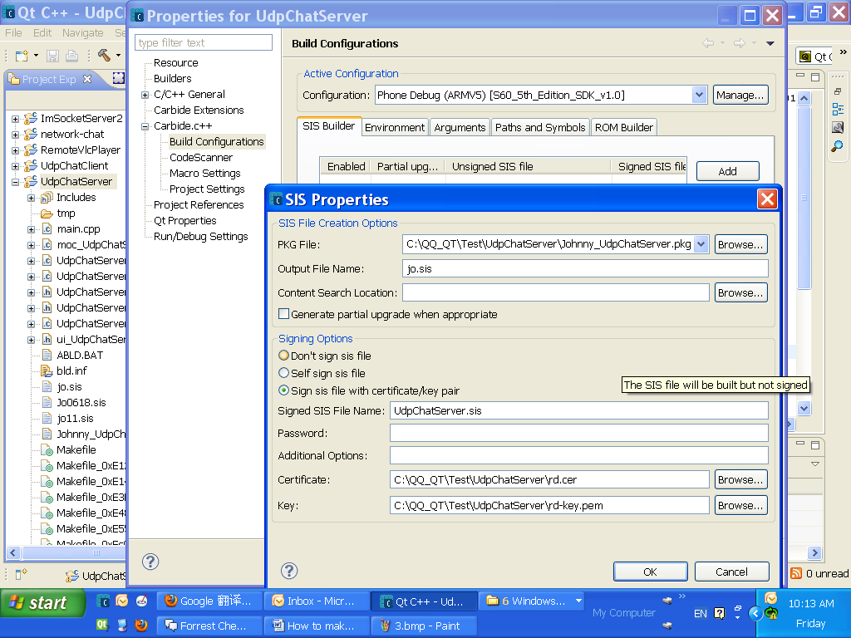

**7.**

After .pkg of your own have already configurated, have two build ways, but the first one is ususlly better than the second one, but sometimes, if you change the codes, the second way is better :

**(1)**The first way as below:

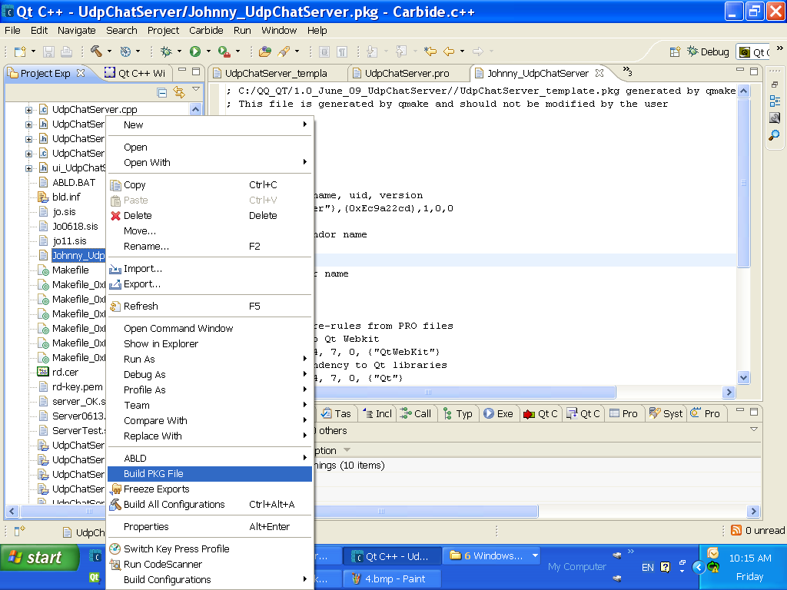

**(2)**The second way as below:

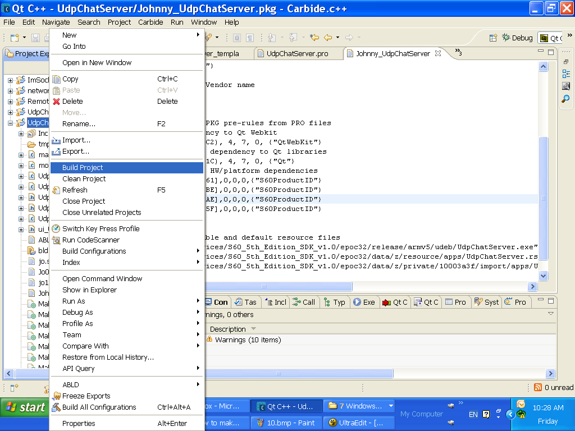

**8.**

The SIS will be generated in your own project file, the diagram as below.

**And I suggest connect those two diagrams with the 6(4) configuration diagram before.**

(1)

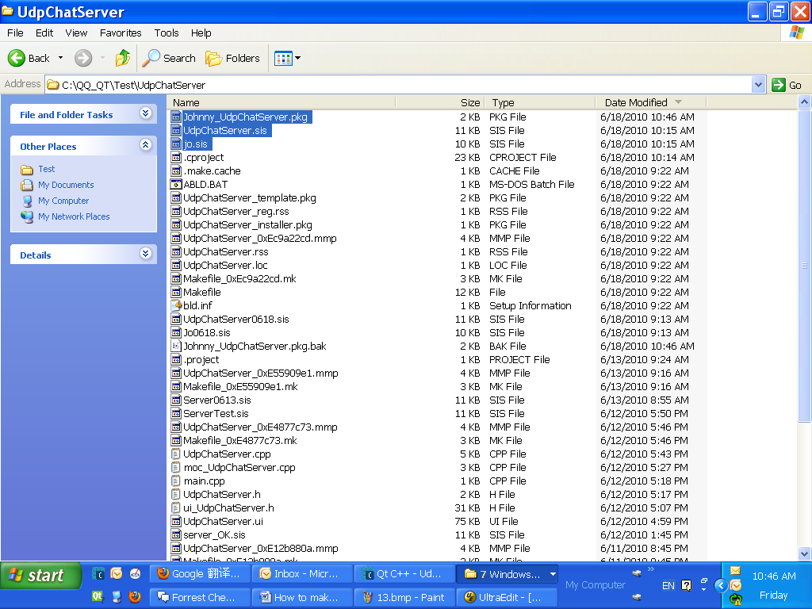

(2)

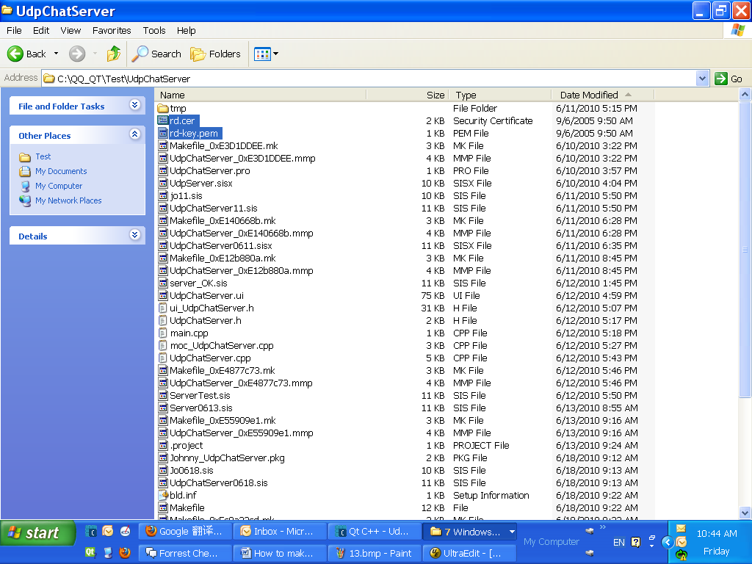

**9.**

If we want to install SIS in the phone, we need to install “qt_installer.sis” which locate in “Qt\4.7.0-beta1” first.

